Research Proposal
Student’s Name
Institutional Affiliations

Research Proposal
Introduction
Registered nurses (RN) perform various functions which are enshrined in their duties and obligations as health officers. Some of the functions they perform include giving patients emotional support, offering health education to the patients as well as serving medication to patients as described by physicians such as doctors (Potter et al., 2016). In fact, nurses do a lot of work in ensuring the well-being of the patients under their care. Since the work they engage in is massive, these Registered Nurses are bound to delegate their duties to other nurses or other health caregivers especially if a patient requires health care over a long period (Potter et al., 2016). Delegation by such nurses involves sharing responsibilities or relinquishing it all together to another person who can accord the patient in question the required health care.
The question that arises from the delegation of nursing care by the Registered nurses is whether the quality of nursing care that reaches the bedside of the patient is affected by the delegation. This is an issue that has been debated hotly in the health sector with some people holding a view that delegation of nursing care by a Registered nurse negatively impacts the quality of service that reaches the bedside of a patient in long tine care and sometimes leads to adverse outcomes in the health of the patients in question. However, some people have held views that there is no such thing as a compromise of the quality of service to the patients if a registered nurse delegates nursing care to another health caregiver in long-term care for a patient.
Therefore, since there is no clear proof on whether the delegation of nursing care in long-term care by a registered nurse affects the outcomes of the care by affecting the quality of service accorded to a patient, there is need to do research on this area to provide clear evidence of the actual situation in the events of delegation of nursing care. Therefore, this research study aims at finding out whether the delegation of nursing care by a registered nurse in long-term care affects the quality of service that reaches the bedside of the patient. This study also seeks to determine what percentage of such delegation leads to adverse effects in patients. This being the case, some of the research study questions that this study will seek to answer include the following:
- Does delegation of nursing care by registered nurses in long-term care negatively affect the quality of the nursing care that the patients receive?
- Does the delegation of nursing care by registered nurses in long-term care positively affect the quality of healthcare that the patients receive?
- Are there other factors that can affect the quality of nursing care that reaches the bedside in the event of delegation or lack thereof?
- Does delegation of nursing care by a registered nurse in long-term care lead to adverse outcomes in the patient care? How likely are such delegation likely to cause adverse outcomes in patient care?
The main hypothesis of this study is that delegation of nursing care by registered nurses affect the quality of nursing care that is reached at the bedside in long-term care. However, the effect might either be positive or negative depending on how the person to which the nursing care is delegated performs her or his duties perfectly or imperfectly. Some of the terms that will be used in this research study include the following:
Registered Nurse (RN)- a nurse who has graduated from a nursing program, therefore, holds a nursing diploma or an Associate Degree in Nursing (ADN) and met the requirements outlined by a country or a state, to obtain a nursing license.
Delegating Nursing Care- Entrusting (a task or responsibility of nursing care) to another person, typically one who is less senior than oneself.
Long-term care-Health care that goes on over a long period such as months or even years.
Nursing care-Refers to services provided by a nurse towards a patient either within a health facility or at home.
Theoretical framework
The theoretical framework that will be employed in this research study is the Caring Science, emanating from the Human caring theory. This theory was put forward by Jean Watson who described the practice of nursing as an activity of caring for a human person with an inner sense of responsibility geared towards creating harmony within the patients, mind, body and soul (Watson & Brewer, 2015). Therefore, according to this theory, nurses take nursing as a profession because they want to care for other and help them to regain hope even in times when all hope seems to be lost (Watson, 1999). Nurses care for human beings by displaying particular caring behaviours towards their patients. These nurses caring behaviours include attentive listening, honesty, comforting, patience, responsibility, providing information to the patient can make an informed decision, touch, sensitivity and respect, not forgetting calling the patient by their name (Watson, 1999).
The rationale for choosing this theory lies behind the fact that this study will be seeking to determine whether delegation of nursing care by RN nurses to less senior nurses affects the quality of nurses. Given that nurses, whether registered or less qualified join the nursing profession because their hearts want to offer interpersonal assistance to patients. The theory of Caring Science is perfect for this scenario because it looks at the science of human caring and factors that lead to that kind of behaviour. The concepts of caring for patients will be explored in this study because they form the basis for this research study. A delegated nursing care is performed Unqualified Nursing Personnel or Assistive Nursing Personnel who might be nurses who are less senior than the Registered Nurse (RN).
Literature Review
A Registered nurse is one who has met all the requirements to obtain a license from a country’s or a states licensing board. This means that such a nurse is qualified to perform nursing functions in a health facility. However, the responsibilities that such nurses are charged with are surely overwhelming. This ranges from the management of the patient education programs within their stations to the offering of moral support as well as health care to the patients within their assigned units of care (McEwen & Wills, 2017). It is because of the overwhelming responsibilities that sometimes the issue of delegation comes in. A Registered Nurse can delegate duty by ordering other nurses who might be less senior than them to person certain tasks relating to nursing care towards the patients (Cherry & Jacob, 2016). However, before such delegation is done, careful assessment is done on the type of task being delegated and the qualifications of the person such task is being delegated to. According to Cherry & Jacob (2016), the careful assessment is done by a registered nurse to ensure that the quality of service reaching the bedside is not compromised. However, does it always happen the way the registered nurses want it to happen? That is the main question that needs to be answered.
As mentioned in the theoretical framework section of this proposal, every nurse chooses the nursing career because they want to offer help and assistance to patents. This simply means that they have a desire to offer care and support to patients suffering from various health complications (Watson & Brewer, 2015). As such, they perform their duties with a lot of diligence and keenness. Before performing a task, they consider and reflect on the good they want to achieve in performing that particular task. Therefore, nurses can be said to have the interest of their patients at heart. This being the case, it can be deduced that no nurse will do anything to harm their patients. This is because they always want to offer moral support comfort and care to their patients which appeal to both body, soul and mind of the patients. Therefore, there is no way they can do anything that can have adverse outcomes to the nursing care that they accord to their patients. As Watson & Brewer (2015), state it clearly, even when tasks are delegated by registered nurses to less qualified nurses, the patient is always in safe hands so long as the nurse to which the task is delegated to follows the instructions and does what is expected of him or her by the Registered Nurse.
A look at what delegation entails in a health facility or a situation of long-term care reveals that a registered nurse can delegate certain tasks to even Nurse Assistive Personnel (NAP)who might not have the knowledge and skills to perform the nursing functions ins a situation of long-term nursing care (Gravlin & Bittner, 2010). Such people might include assistive Nursing personnel who might not be necessarily nurses but who might help in offering the much-needed nursing care to the patient. In such cases, if the delegation of nursing care is done by a registered nurse in a situation of long-term care, then the health of the patient is put at risk (Gravlin & Bittner, 2010). This does not only jeopardize the quality of the services reached to the bedside but also puts the license of the Registered Nurse at Risk. This is because the license of a registered nurse can be revoked if it is discovered that his or her delegation practice resulted in adverse effects that compromised the health of the patient.
The possibility of revoking a registered nurse license for failed delegation puts every registered nurse on high alert when doing delegation. Every registered nurse is fully aware that even though they can delegate their duties to other nurses as well as nurse assistive personnel, they should do that according to the standards and conceptual framework that allows for the same. The delegation should be done within the circumstances allowed by the ethical code of conduct for nursing professionals (Hasson, McKenna & Keeney, 2013). This means that scrutiny of the tasks and their possible outcomes of any practice being delegated have to be done before the actual delegation happens. However, it means that even if it is in a long-term care situation, the Registered nurse remains responsible for the delegated activities. This being the case, nurses no that they have to monitor and supervise and ensure that all is well with their patients (Hasson, McKenna & Keeney, 2013). They cannot just delegate and assume that all will be well since the responsibility for the delegated duties and tasks still lies with them. This being the case, it is hard to comprehend how delegation of nursing care by a registered nurse in a long-term nursing care can result to adverse outcomes for the patients. It is also difficult to understand how the quality of nursing care reached to bedside can be compromised with appropriate delegation of tasks by a registered nurse, particularly in a health facility.
Methodology
The type of research study
This study will be both qualitative and quantitative. This is because of the fact the main objective of the study is to determine whether the delegation of nursing care by registered nurses (RN's) affect the quality of the nursing care reached to the bedside in long-term care as well, as determining the percentage of the delegation cases that result to adverse outcomes. The information to be collected will be both qualitative and quantitative. A qualitative approach will be the most appropriate because mostly, the study will be qualitative because the information required cannot be quantified but can only be used to come up with quantitative deductions during the analysis. The collected will seek to determine if at all there is a compromise of the quality of nursing care in cases of delegation by registered nurses and then the analysis will look at how many among the delegated cases result to adverse effects.
The research design
This research study will take a descriptive design approach. A descriptive research design provides answers to questions of whether delegation by registered nurses affects the quality of nursing care reached to the bedside. The study will aim at describing the situations and any other factors that might play in the case of delegation to affect the quality of care in long-term care situations. As a descriptively designed study, it will help to provide answers to the question of how adverse outcomes are realized in cases of nursing care delegation by registered nurses in long-term nursing care situations.
The rationale for choosing a descriptive research design for this study lies in the fact that this research study will be seeking to identify what happens in delegation of duties by registered nurses and finding out the quality of nursing received when such delegation happens and the overall effects which have an underpinning on the outcomes of such care in long-term nursing care situations.
Study participants
The participants of this study will be nurses and long-term nursing care patients of Stanford Hospital between June 2nd, 2018 to September 30th, 2018. The nurses in this hospital will take part in this study voluntarily by filling questionnaires and online surveys anonymously. The patients will also take part in the filling as well as responding to the questionnaires either in writing or through tape recording. However, the study will exclude those patients who will be critically ill. The focus will be on those patients who can speak and who can read and write despite their medical conditions. However, the patients will have to be those who are in the hospital for long-term nursing services. The nurses will play an important role in giving the questionnaires and survey papers to the patients for those who will want to respond to them in handwriting. However, they will also be provided online so that the patients, as well as nurses, respond to them on their phones and computers as well as tablets.
Data collection
During this research study, information will be collected through questionnaires, interviews, surveys, use of secondary sources and observation. Both nurses and patients will fill questionnaires at the hospital. However, observation will also be combined to offer authenticity to the information collected. Observation will help to provide answers to vague answers as well as ambiguous answers to the survey and questionnaire questions. Secondary sources such as nursing research articles and primary nursing studies will be used to gather information that can provide answers to the research questions of this study. The internet is a source of information and as such, it will also be used but a lot of care will be applied to ensure that only the useful and credible sources of information will be.
Protection of Human Subjects
To ensure that the identities of the participants of this research is hidden, the surveys and questionnaires will be filled anonymously. Furthermore, interviews will be conducted in a manner that each participant will be interviewed separately from others to ensure that their responses remain private and anonymous to other participants of the study as well as to the general public. Furthermore, consent forms will be given to the participants and will be read and signed before participation. Furthermore, participants will be given an opportunity to ask questions regarding the study to have a full understanding of the study they will be taking part in.
Data Analysis and Presentation
The data collected will be analyzed by reading through the responses provided by the participants and making deductions as well as inferences from them regarding the topic of research. Main focus will be whether the information suggests a change in the quality of nursing care in the event of delegation or not. Of importance during the analysis of the responses will also be the general feeling brought out from the responses about the connection between the delegation of nursing care by RN’s to adverse outcomes in cases where unexpected outcomes are realized by patients.
A record will be kept of the number of participants and the number among those who exhibit adverse outcomes in long-term nursing care. This will be of help in the calculation of the percentage of delegation cases that lead to adverse effects. This means that percentage of the same will have to be calculated statistically and quantitatively. The results of the research study will be presented using charts. The charts will outline the common factors that play in situations of long-term nursing care to determine the quality of nursing care reached to bedside. Pie charts will be used to display the percentage of delegation cases resulting to adverse outcomes against those resulting to desired outcomes.
Applicability to Nursing
This research is viable and applicable to nursing. Some of the nursing areas that will benefit from this research include nursing management which is the main area in which Registered Nurses operate in their careers. Another nursing area that will benefit from this study is the nursing patient education which borrows a lot from the theory of Caring science because nurses educate their patients with the objective of offering support and care as well as understanding and respect that appeals to their bodies, souls and minds.

References
Cherry, B., & Jacob, S. R. (2016). Contemporary nursing: Issues, trends, & management. Elsevier Health Sciences.
Gravlin, G., & Bittner, N. P. (2010). Nurses' and nursing assistants' reports of missed care and delegation. Journal of Nursing Administration, 40(7/8), 329-335.
Hasson, F., McKenna, H. P., & Keeney, S. (2013). Delegating and supervising unregistered professionals: the student nurse experience. Nurse Education Today, 33(3), 229-235.
McEwen, M., & Wills, E. M. (2017). The theoretical basis for nursing. Lippincott Williams & Wilkins.
Potter, P. A., Perry, A. G., Stockert, P., & Hall, A. (2016). Fundamentals of Nursing-E-Book. Elsevier Health Sciences.
Watson, J. (1999). Nursing: Human science and human care: A theory of nursing (Vol. 15, No. 2236). Jones & Bartlett Learning.
Watson, J., & Brewer, B. B. (2015). Caring science research: Criteria, evidence, and measurement. Journal of Nursing Administration, 45(5), 235-236.

Appendices
Appendix A

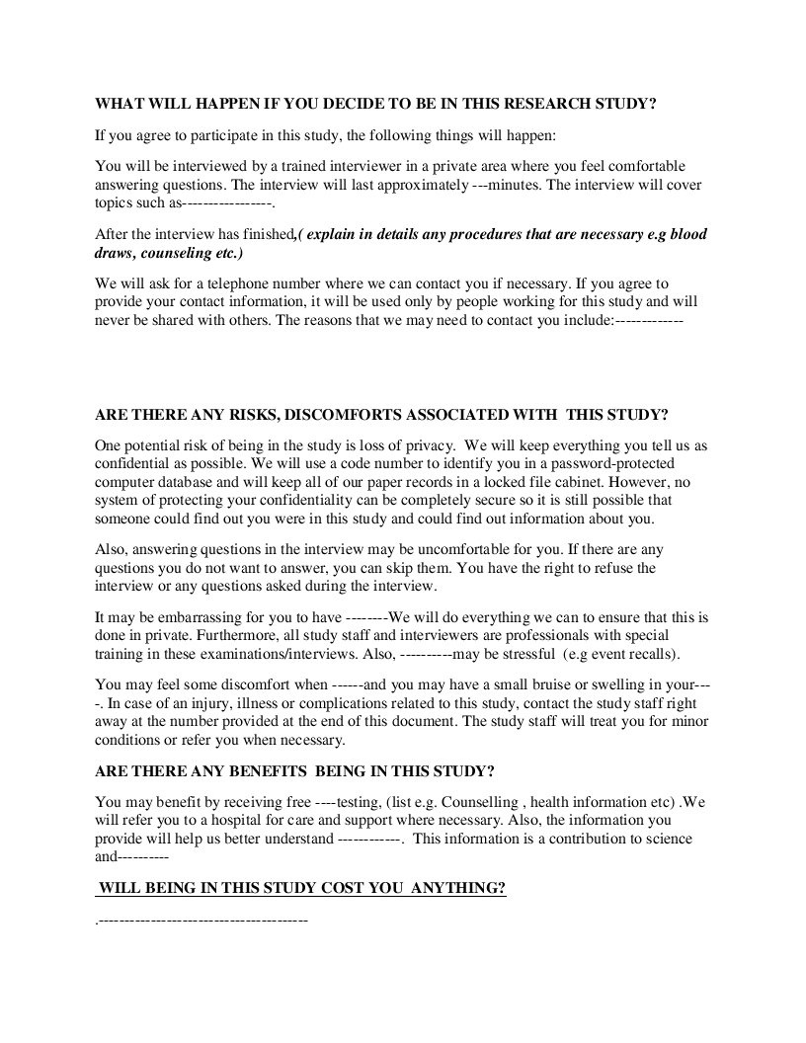
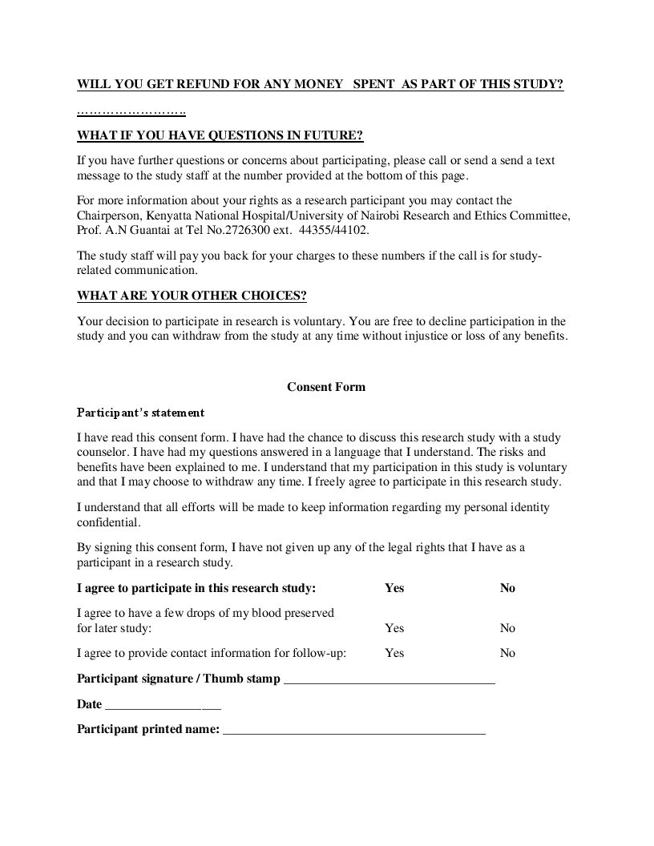


Appendix B: Questionnaire Questions
